November 1, 2021

Brendan Wallace-Nash

N9993304

MGN565

Change plan for scenario planning

Scenario planning for the next 20-30 years has indicated that the Commonwealth Bank must acknowledge and prepare for industry shifts. A previously conducted scenario planning process highlighted the potential of numerous threats to Commonwealth Bank, that not only presented a threat to the Commonwealth Banks business model but also present an opportunity for market competitors to take advantage of. This report will outline the effects of a future where hyperinflation is present and a management plan for the commonwealth bank to undertake, which will include interventions and strategies to prepare and take advantage of this possible future scenario.

# **Implications of Scenario Planning**

           The future scenario planning suggested that there is a probable likelihood that Australia could face hyperinflation within the next 30 years. As a result of hyperinflation, it was highlighted that the Commonwealth Banks current model of offering savings accounts that earn interest and then repackaging invested money to make loans could be drastically impacted by the volatility of hyperinflation. Hyperinflation can often lead to a rise in common goods by up to 50% a month, this often leads people to turn away from the use of savings accounts (0.05% per annum) and put their money in an asset that will be able to minimise the potential loss of monetary value in their savings (Tscach, 2000). There have been many different mitigations identified to prepare for such a scenario but one of the most adaptable plans to the Commonwealth Banks current model is to start offering cryptocurrencies through CommSec to allow customers to maintain their economic value in a fluctuating market. The cryptocurrencies will be sold through CommSec, and the banking sector will offer higher interest rates on the assets (like the 5% A.P.Y offered on other cryptocurrencies) to ensure the Commonwealth bank maintains cash flow to make financial products in a time of hyperinflation.

# **Situation Analysis and Change structure**

           The following table will incorporate the McKinsey Seven-S Framework to demonstrate the current state of the Commonwealth Bank, the state they need to be in to prepare for hyperinflation and the gap between the two states and incorporate the whole system (Waterman, 1980). This table will mostly look at how the Commonwealth bank will need to transition to have a cryptocurrency department, with some aspects of what will have to change to incorporate cryptocurrencies into CommSec’s financial offers mode.

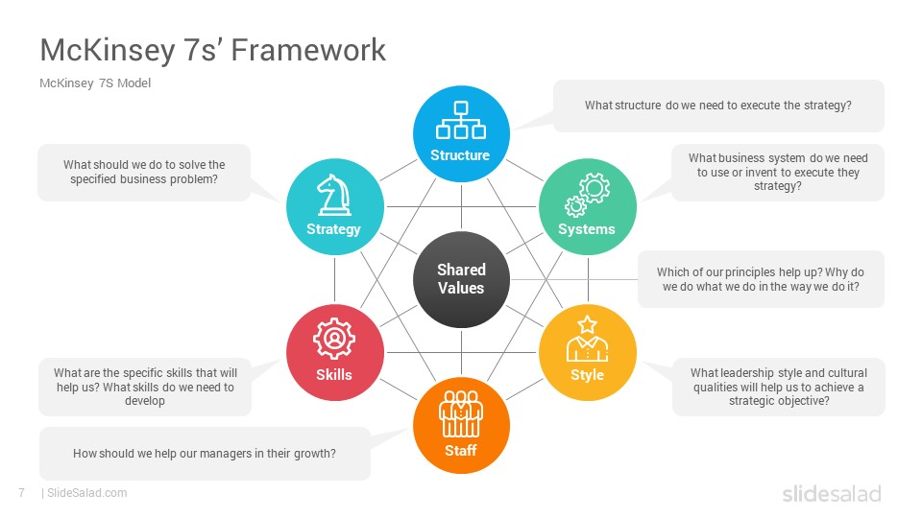

Figure : McKinsey 7's Framework

Table : McKinsey 7's Framework for development of Change to Mitigate Hyperinflation

|  |  |  |  |  |
| --- | --- | --- | --- | --- |
| Diagnosis | Current State | Future State | Gap | Urgency |
| Strategy | **The current state of the Commonwealth Banks strategy is to offer savings accounts with interest rates to attract customers to keep their money with them so the bank can then use that money to create financial products and loans to earn interest and make money from (The Org, 2021).** | **Offer a wide range of saving accounts to customers with products such as cryptocurrencies that can be a good hedge against inflation. The money used to invest in cryptocurrencies and fees used for buying and withdrawing coins can be used to make finical products and loans.** | The gap between the two strategies may not sound that large as the strategy is just changing from offering savings accounts in Australian dollars to cryptocurrencies but there must be a shift from expertise in financial knowledge to cryptocurrency knowledge. | Very High |
| Structure | The current structure of the Commonwealth bank is that of a mechanistic structure top-down (The Org, 2021). | An organic structure should be utilised in the future as it will allow the cryptocurrency department (CommSec) to be flexible to alternative approaches as there won’t be a centralised figure. Having a centralised head to the department from a banking background could lead to the transition to cryptocurrencies being managed as a typical financial product, thus potentially leading to oversites in newly emerging ways to utilise cryptocurrencies. | The main gap in structure is to shift from the current rigid structure to a more organic flexible structure that can adapt to the evolving market of cryptocurrencies. Doing so will allow for a better synergy of cryptocurrency experts and banking experts to find the best way to present a cryptocurrency product that is in line with the Commonwealth banks model and core values | Moderate |
| Systems | The Commonwealth Bank is becoming more data-driven in decision making as it slowly moves to an online platform (Commonwealth Bank, 2021). | **in the future state, the potential of hyperinflation could mean that the Commonwealth bank would have to be offering more attractive products to the customer to ensure that they are keeping their money with them and not moving it into other assets. A fully data-driven system would be needed to provide quick and accurate consumer insights to provide products to their wants.** | The gap between the current state and future state is very minimal as the current system is heading towards the data-driven system that is needed for the future state. | Low |
| Staffing | **Currently, brick-and-mortar locations are only available for Commonwealth bank services and not CommSec services. There has also been a mass reduction in brick-and-mortar locations over the last couple of years (Rubbo, 2020). Furthermore, CommSec consultations can only be made through phone appointments during the hours of 8am to 7pm (CommSec, n.d.). There is also staffing segregation between Commonwealth Bank staff and CommSec staff. The two types of staff do not have any means of communication and practice as staff from two different companies.** | The Commonwealth Bank should still maintain their brick-and-mortar stores as it will allow for non-tech savvy customers to be able to inquire about the transition to using Cryptocurrencies, although a bigger focus on becoming an online facing company will be needed to allow for 24/7 service. There should also be a level of overlap in knowledge between Commonwealth bank staff and CommSec’s staff. As the cryptocurrency market is volatile and often more active during the American trading hours there should also be a shift to 24/7 support lines for CommSec’s. | **Currently, there is an decrease in the Commonwealth banks brick-and-mortar stores but they will need to keep some open to help people transition. We will also need there to be a greater understanding between staff of the finical packages on offer between divisions. This could allow banking staff to direct clients that want finical products that can offer higher returns to counteract hyperinflation to investigate the cryptocurrencies offered by CommSec’s. CommSec’s employees will need to develop an understanding of the cryptocurrencies that will be offered and start to provide 24/7 support to accommodate the globalised nature of cryptocurrencies.** | High |
| Style | The Commonwealth bank uses a team style approach, comprised internally of effective members for the problem at hand. the Commonwealth bank also currently conducts a participative leadership style, which promotes all members of the business to feel active in providing input. The cooperative culture at the Commonwealth Bank also supports innovation and creativity (Commonwealth Bank, 2021). | **The current team-based participative leadership style suits what would be needed of a cryptocurrency transition as it will allow for a wide array of ideas and solutions to conflicts to help at the change’s inception. The Commonwealth Banks policy for innovation and creativity will also aid the development of a cryptocurrency department as it will allow them to build an identity for the department that will act as a guideline and standard expected from the department.** | **There is no definitive gap between the current state style and the desired state style. This is because the transition to using cryptocurrencies and financial products is much suited to the style and approach the Commonwealth bank already undertakes.** | Low |
| Skills | Currently, the commonwealth bank staffs and CommSec staff skills set are based around financial products and asset trading. As established previously there is very little overlap in skills between the bank staff and trading staff, as the two have little to no understanding of the other department. | For Cryptocurrencies to be offered as a wide range of financial products there is a need for both Commonwealth bank and Commsec employees to have an overlapping understanding of how the Commonwealth bank intends to use cryptocurrencies. | There is a need for overlap in skill between the two positions. Both staff types need to be aware of the cryptocurrency products on offer and direct cliental to the right departments. | High |
| Shared Value | Currently, the Commonwealth bank promotes shared values in innovation, collaboration, excellence, accountability, and service (Glassdoor, 2021). | In terms of shared values, the future state will be acceptive of the current state’s values. | Shared values are the Commonwealth needs to prepare to be held accountable if the cryptocurrency products they produce do not hold up to the level of excellence in service they portray to their clients and be able to hold themselves accountable. | low |

# **Change goal**

           The goal is to be able to offer cryptocurrency financial products within the next 30 years, to mitigate the risk of inflation. To do this the Commonwealth bank will first have to develop a cryptocurrency department. This department will then decide what cryptocurrency products are in line with the commonwealth banks values and strategy, and how they can offer them to the consumer.

# **Interventions to be Considered to Reach Change**

           Table 2 will highlight the gaps established in table 1 and implement optional intervention strategies that would be best suited to closing these gaps. Table 3 will be based on the use of Kotter’s 8 Steps to give a detailed explanation of how the intervention for change in strategy could potentially be implemented (Kotter, 2012). It should be noted that the most important factor in making change happen is acceptance of change on both a top-level structurally and an overall general culture in the company, without this change cannot be facilitated.

Table : Optional Interventions

|  |  |
| --- | --- |
| Identified Gaps | Optional Intervention |
| Strategy: Shift from Australian dollar backed finical products to Cryptocurrency backed | I would recommend using Kotter’s 8 steps to build a sense of urgency and motivation to move towards the use of cryptocurrencies as financial products. Kotter’s intervention model has a large focus on building motivation through top-down change and the use of a coalition of like-minded change actors. The shift from fiat (government currency) and cryptocurrency is the largest and most important gap at present, and the use of the top-down structure will likely be suited to the Commonwealth banks current top-down structure. |
| Structure: shift from mechanistic to organic structure (specifically in the cryptocurrency department) | **To implement a structural change from the typical mechanistic structure at the Commonwealth Bank to that of an organic approach should be implemented in the vision created in the forming of your change coalition. It should be noted that a change to an organic structure will mean higher up staff will have less authority and thus joining the coalition may not be perceived as an attractive offer.** |
| System: The bank becoming more data driven | The gap between the current state and desired state in terms of the system is very minimal as the Commonwealth bank is naturally progressing towards the desired state. There is no need for intervention as the natural course will likely lead to the future state. |
| Skills: developing a shared skill set between banking and exchange staff | Developing shared skills between banking and exchange staff will require the use of human resources to provide a training program. Again, Using *Kotter’s 8 Steps* would by creating a sense of urgency among human resources to build a vision of change to staffing skills. |
| Staffing: Moving towards a staffing schedule that allows Commonwealth bank customers access to 24 hour support | The importance of being able to provide 24/7 support is important in the gradual move to using cryptocurrency. This should also be a gradual goal with small milestones placed on extending phone and online support. With the continual closing down of brick-and-mortar stores, we could try and transition retail staff to support service staff as they will already have the values and knowledge that would have to be trained for the newly hired support chart. |
| Style: There was no identifiable issue between current style and future style. | There was no need for a change in style. The commonwealth bank will already be undergoing a huge change from fiat financial products to cryptocurrency-based products, there is no need to unnecessarily change the companies’ style. |
| Shared Values: Current values will be suited to the required future values. | The current values and culture of integrity and accountability will be very relative to what will be needed in a time of hyperinflation. During hyperinflation, people will be looking for guidance in what to do with their assets. Accountability could be shown by the Commonwealth bank by demonstrating knowledge that their current products are not functional in this climate and that they will be transitioning to an asset class that can offer their clients better return. |

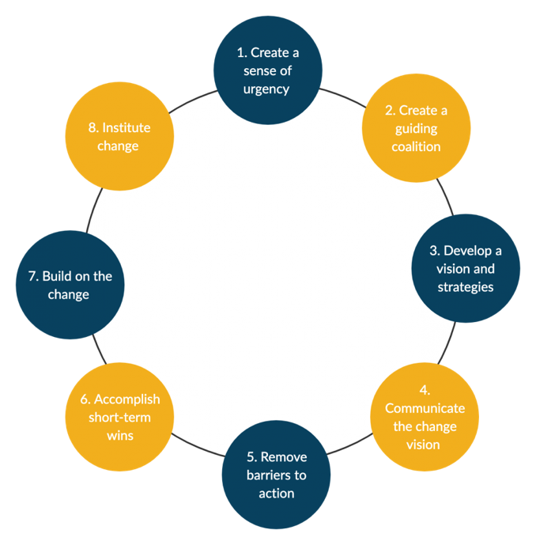

Figure : Kotter's 8 Steps of Change

|  |  |  |  |  |  |  |  |  |
| --- | --- | --- | --- | --- | --- | --- | --- | --- |
| Identified Gap | Create Urgency | Form a Powerful Coalition | Create a Vision for Change | Communicate Vision | Remove Obstacles | Create Shot-Term Wins | Build on the Change | Anchor Change in Cooperate Culture |
| Shift from Australian dollar backed finical products to Cryptocurrency backed | Urgency should be used to build motivation in the commonwealth bank. This should start at the highest level by demonstrating the market share the Commonwealth Bank could lose to Cryptocurrency exchanges with the emergence of hyperinflation in the next 30 years. | Identify true leaders and key figures within the Commonwealth, like Angus Sullivan (Group executive and retail banking services) to invest emotional commitment in building a change coalition. Have the coalition made up of a diverse set of skilled people to mitigate weak areas and oversights. | Develop a precise set of values that are going to summarise your coalition’s goal of changing to cryptocurrency products. Have the vision tangible by all members and perceived executable by all. | Identify people’s anxieties about a move to cryptocurrencies. This is a new product that has plenty of concerns surrounding it. Establish methods to mitigate concerns. | Quickly act to remove potential barriers to change, whether that is human or structural barriers. Identify potential talent that could help lead change. Put an emphasis on trying to hire from within as it could convey a growth in change from within the company. | Treat growth in coalition and support from high-level officials as small millstones. Have the major millstone be the creation of a flagship crypto product to promote within the Commonwealth | Continually analyse after every step to establish what went right and what went wrong. | Use your success to establish new members in your coalition that will replace leaving ones and develop a culture of change. |

*Table 3: Kotter's 8 Steps Implemented on Strategy Change*

# **Change of Strategy Plan**

           Table 3 outlines the use of Kotter’s 8 steps to implement change in strategy. The plan focuses on creating internal change by promoting from within and building a sense of momentum around the change to cryptocurrency-focused products. Building a motivated team from within is also cost-effective which will allow for this change to develop more gradual over time as high-level staff will not be looking for a return on investment. The GAANT chart below shows a road map for facilitating change to be used by change management and Human resources. Key millstones are identified as getting support from key leaders, growing a coalition of change leaders and establishing a flagship cryptocurrency product to promote amongst high-level colleagues.

# **Ethical Concerns**

           It should be considered that the current change plan to cryptocurrencies presents an economical risk to staff and consumers. In terms of consumers, cryptocurrencies are still a volatile asset and not providing clients with a high level of due diligence could financially cripple clients that trust the Commonwealth bank with their money. Furthermore, the shift to cryptocurrency products will see many staff made redundant. The Commonwealth Bank should look at employing a phase-out plan, that would allow for staff that will no longer be needed to be relocated to different positions or upskilled to emerging positions.

# **Concluding Statements**

           Inactivity in a time of constant change will lead to this companies’ stagnation, that is why a change plan for the next three decades is so important. The change plan outlined only demonstrates the first few months of what will be a decade's long change. It is important to remember the necessity of this change, to keep the Commonwealth banks market share for a future where hyperinflation is an ever-growing threat. Once the Commonwealth Banks culture begins to adopt cryptocurrency products, continue growing the change coalition and build upon the flagship of cryptocurrency products for the future.

# Bibliography

Commonwealth Bank. (2021). *Corporate Governance*. Retrieved from Commbank: https://www.commbank.com.au/about-us/shareholders/corporate-profile/corporate-governance.html

Commonwealth Bank. (2021, Septembet 17). *Govt recognises CBA’s digital features and data analytics as ‘innovative’* . Retrieved from Commbank : https://www.commbank.com.au/articles/newsroom/2021/09/CBA-data-analytics-innovative.html

CommSec . (n.d.). *Contact Us*. Retrieved from Commsec.com.au: https://www.commsec.com.au/support/contact-us.html

Finextra. (2004, May 18). *Commonwealth Bank restructures for CRM*. Retrieved from Finextra: https://www.finextra.com/newsarticle/11838/commonwealth-bank-restructures-for-crm

Glassdoor. (2021). *Commonwealth Bank of Australia*. Retrieved from Glassdoor: https://www.glassdoor.com.au/Interview/The-CBA-core-values-consist-of-integrity-collaboration-excellence-accountability-and-service-What-are-your-own-person-QTN_1762188.htm

Kotter, J. P. (2012, November). Accelerate! *Magazine*, p. https://hbr.org/2012/11/accelerate.

Rubbo, L. (2020, May 7). *Commonwealth Bank temporarily closes 114 branches, 500 staff affected due to coronavirus impacts*. Retrieved from ABC News: https://www.abc.net.au/news/2020-05-07/cba-temporarily-shuts-branches-to-deal-with-covid-19-issues/12225160#:~:text=Commonwealth%20Bank%20has%20closed%20114%20branches%20across%20the,a%20drop%20in%20patronage%20during%20the%20COVID-19%20pandemic.

The Org. (2021). *Commonwealth Bank of Australia*. Retrieved from The Org: https://theorg.com/org/commonwealth-bank-of-australia

Tscach, I. (2000). *The Impact of Inflation on Long-Term Housing Loans.* Retrieved from econstor: https://www.econstor.eu/handle/10419/76905

Waterman, R. P. (1980). *Structure is not organisation. Business Horizons.*

Winterford, B. (2010, September 30). *project, Inside the CBA's Oracle-as-a-service*. Retrieved from IT News: https://www.itnews.com.au/news/inside-the-cbas-oracle-as-a-service-project-233738